SHROVE TUESDAY will be celebrated in St Edmund’s Church Hall on Tuesday 17th February 5-7 pm. There will be sweet toppings as well as cheese. There will be a fantastic raffle. Donations for the pancakes are welcome.
There will be a Confirmation service on 23rd June which will be led by Bishop Libby. The venue is still to be decided. If anyone who hasn’t been confirmed and would like to know more, please speak to Rachael.

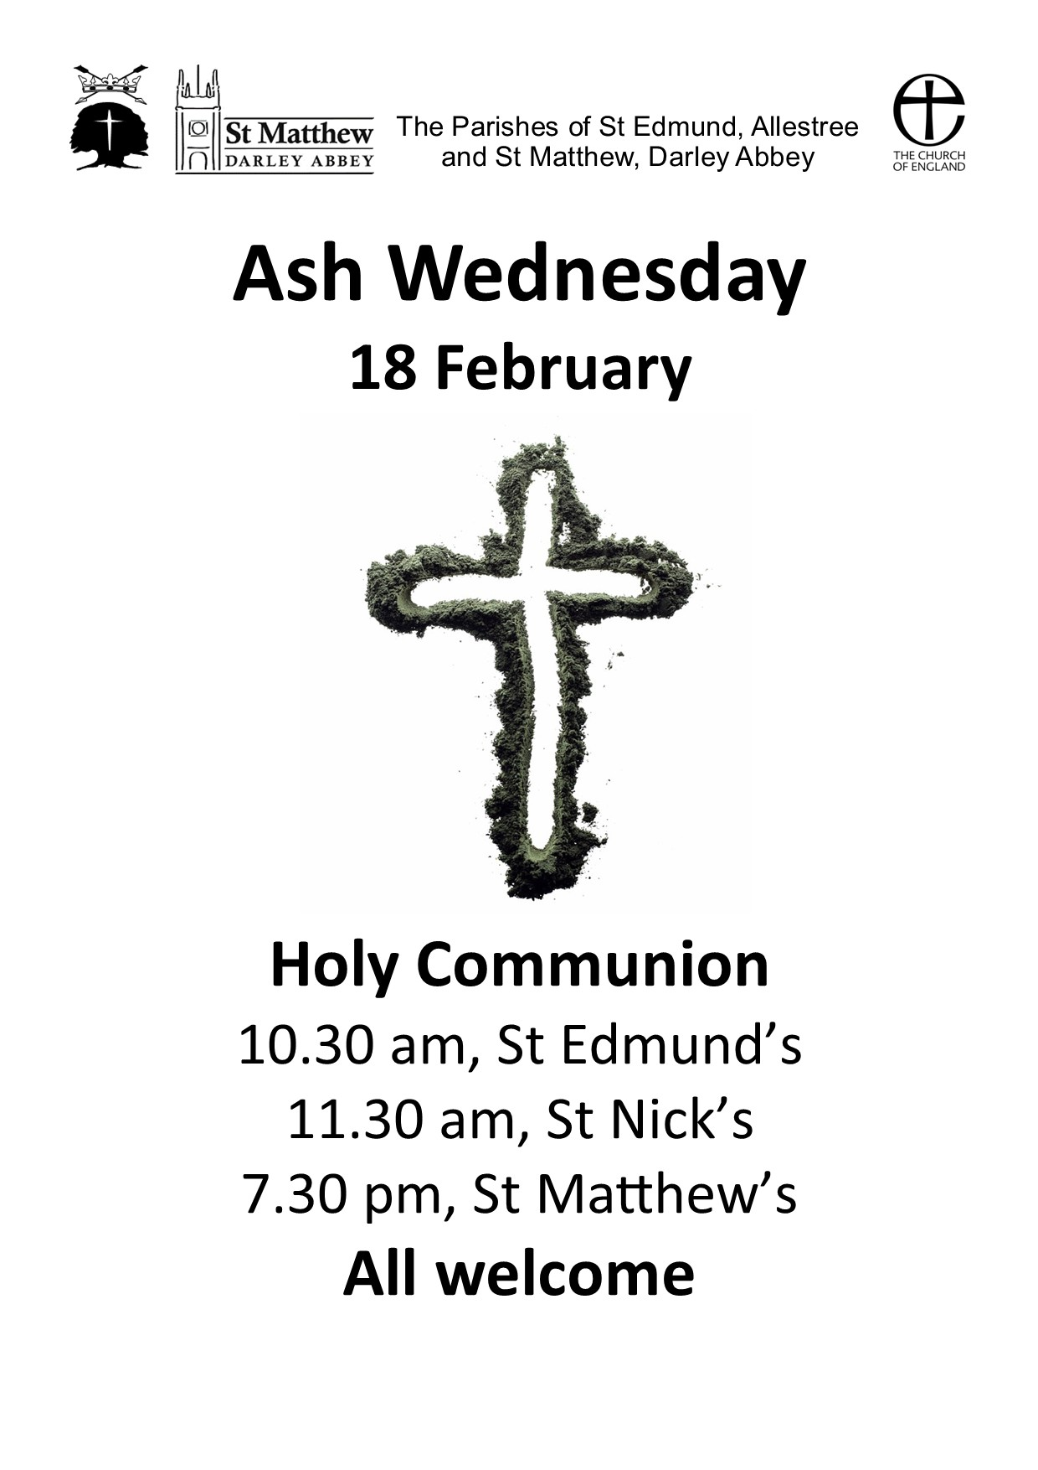
The next ALL AGE SERVICES will be on 25th January at St Edmund’s and 1st February at St Matthew’s. The theme will be Leah and Rachael who were sisters. As always, the services will be informal, interactive and suitable for all ages. All welcome.
THE COMING WEEK
Monday 19th January
9.30-12 noon - St Matthew's carpark –
Refills on the Road
Holy Communion - 10.45 am at Stanley House and 11.20 am at Abbeydale
​
Tuesday 20th January
12 noon - Luncheon Club
​
Wednesday 21st January
10.30 am – St Edmund’s – Holy Communion,
led by Rachael Brooks
​
Thursday 22nd January
10 am – St Edmund's Church Hall –
Baby & Toddler Group

Sunday 25 January 2026
The Third Sunday of Epiphany, and the Conversion of St Paul
10 am - St Edmund’s – Choral Holy Communion
led by Adrian Thorp
10 am - St Matthew’s – All Age Worship
led by Rachael Brooks and the Team
6 pm - St Edmund’s - Choral Evensong
led by Rachael Brooks

